Nigar Hətəmova
Azərbaycan Dövlət Rəsm Qalereyasının kiçik elmi işçisi
Email: negarhhemi000@mail.ru

Silent Language of History

Carpet and rug aesthetics, filtered from the colander of history, have the function of carrying all the characteristics of a century and people. Rugs and carpets are the products that reflect the joy, pain, family structure, customs and traditions of our nation for hundreds of years, and have traditionally decorated covers and mats. Tapestry-woven products, which are constantly renewed with traditional motifs in the historical process and respond to the rarest works of art that show the creativity of a nation. The Azerbaijani nation’s acquaintance with carpets and introducing it to the world with a unique mastery is related to their own lifestyle, values and lifestyle. Turkish tribes, who lead a nomadic lifestyle and have a certain tradition, weaved carpets and rugs from those wool yarns by spinning the wool and dyeing it with the roots of the plants in order to protect the area they live in from dirt and filth, sit on a clean floor and stay warm. They laid them out on their seats and hung them on their walls. At the same time, this was the importance and value given to people, living space and cleanliness, and it was civilization itself. These nations for centuries; has been expressed love and all feelings in the symbolic language of colors and embroidery. The art of carpet and rug weaving also greatly expanded the field of natural dyeing. The peoples living in the regions dominating the Silk Road are also developing their commercial habits at a very high level through the art of carpet and rug weaving. Carpets and rugs adorned with motifs intertwined with nature and unique patterns have emerged due to both these reasons, artistic inclination and needs. We can say the name of the world’s first known carpet, the Pazirik carpet, which was discovered in 1948 as one of the first samples of the carpet that has been needed since the beginning of human history.
The art of weaving was born and developed with domestic of animals by sedentary people about 10 thousands years ago. Although weaving was born as a result of human needs in the beginning, it later developed and became a social and artistic identity that found a place in all lifestyles rather than being a necessity. Therefore, carpets and other woven mats are very important documents that reflect the culture, belief, traditions and customs of the society. Just as human beings have symbolized their beliefs in tombstones, obelisks, monuments and works of art, they have also transferred their beliefs and traditions to carpets and rugs with certain symbols.
The first traces of weaving are seen in Anatolia. The presence of tissue weights, needles and wool bending tools dating back to the 7thmillenium BC in the archeological excavations carried out in the Konya-Chatalhoyuk settlement, as well as the capture of tissue particles, proves that weaving has a place in human life. In the Gordion excavations, the capital of the Firig Uyghur, pieces of geometric patterned wool and line fabric dating back to the 8th-7th centuries BC were also found. The state and rugs of the Firigs, which are called as ‘Tapetenes’ or ‘Tapestry’, have made a name for themselves in art history of art.
The important samples of Anatolian carpet art are woven in Konya, Begshehir, Aksarai and Sivas during the Anatolian Seljuk period in the 13th and 14th centuries. This period, when the most magnificent carpets of the time were woven in the world, is in fact considered to be the first brilliant period of world carpet weaving. The characteristic feature that gives the Anatolian Seljuklu carpets, which are very dazzling in terms of color and motifs, a monument quality, is a wide border and a large Kufic writing décor. In addition, the in a composition is rich, different tones of the same color are applied harmonious way. The Anatolian Seljuk carpets discovered with the first Konya group (8 units), followed by Begshehir (3 units), Fustat (7 pieces) and Sivas (5 units) groups, take their place in the world knowledge literature.
Discovered by research in recent years, characterized as the Tibetan group and 12-14. It is known that 5 pieces of carpets dated to the centuries have a common peculiarity with their technical features, color and décor, other Anatolian Seljuk carpets. For this reason, it is thought that this group was exported to Central Asia by touching to order in Anatolia.
In Anatolia, Seljuk carpets are replaced by animal figurines from the middle of the 14th century. The weakening of the Anatolian Seljuk state at the beginning of the 14th century and the Mongol invasion that disrupted Anatolian unity gave birth to a new art style in addition to the classical Seljuk art. Animal-shaped rugs originating in Central Asia and the Far East are beginning to be seen. In fact, animal-figured carpets, which have been seen since the time of the Anatolian Seljuks, have been exported, especially during the 14th and 15th centuries. In the paintings of European artists such as Crivelli, Carpaccio, Ferrara, Lorenzetti, Huguet and Buanacorso, we encounter animal figurines. In Anatolia, in the 15th century, geometric patterns that we see in the paintings of European artists such as Crivelli, Memling, Holbein, Lotto and Bellini appear. These types of rugs are more common in Western Anatolia, as well as in Central Anatolia and Eastern Anatolia. From the 11th century onwards, the art of carpet weaving spread from Central Asia to the west under the rule of the Seljuk Turks and with them. The names dividing the geographical origins of the carpet types are given according to the province, district and villages where the carpets are woven. Among these, the carpets made by the nomad (nomad) and semi-nomad tribes are directly referred to by the names of the tribes. In Turkish, Yoruk is used in the sense of nomad. The carpets woven by the nomads wandering around the Gerus region in the western part of Iran are called "Gerus carpets". The Circassians living in Dagestan in the Northeast Caucasus Region and the Chichi tribe in the Caucasus gave their names to the carpets they weaved. These are well-known types of carpet. Carpets woven in these regions have many names due to the multitude of tribes. However, these carpets are named not according to the places they are woven, but according to the places where they are marketed or collected for sale to merchants and for export. Since many types of carpets woven in Anatolia are gathered in İzmir for sale, they are called "İzmir carpets" even though they are not woven in İzmir. Southern Persian carpets. They are known as "Meccan carpets" since they were offered for sale in Mecca, the birthplace of Muhammad. “Mosul carpets” because carpets woven in Northern and Central Iran and northern Iraq are brought to Mosul for sale, “Bukhara carpets” because carpets woven by Turkmen nomads are marketed in Bukhara, and carpets woven in Kotan and other cities of Chinese Turkestan are sold in Samarkand. It is famous with the names of "Samarkand carpets". Sometimes carpets are named according to the knot technique used in their weaving. Carpets woven with Turkish knots are called "Turkish knotted rugs", and rugs knotted with Iranian knots are called "Iranian knotted rugs". Although most of the Southern and Eastern Persian carpets are knotted with the Persian knot; The Gordes knot (Turkish knot) is used in carpets woven in the Khorasan region of Northeast Iran. Izmir rugs; These rugs, which are quite coarse and generally woven in imitation of Iranian patterns, are known as "Izmir carpets" because they are not made in Izmir, but are brought from the well-known carpet centers of Anatolia for export and marketed in Izmir. Ladik carpets; A straight branch and patterns consisting of large tulip motifs placed on it characterize the Ladik prayer rugs. Tulip motifs are always hanging down. The fact that the carpet floor is divided into two halves is another feature of these carpets. There is a mihrab in the larger upper part, and tulip patterns in the smaller lower part. Compared to other prayer rugs, the mihrab or niche of the Ladik prayer rugs is decorated with various hills. The most important feature of a good Ladik carpet is that the floor is brick red and reddish dull blue. Usually, there is a tree of life pattern on one side of the mihrab.
Bergama carpets; These carpets are woven in the historical city of Bergama in Western Anatolia, close to the Aegean Sea coast. The most prominent feature of Bergama carpets is that the geometric patterns are very prominent. Its edges mostly show straight and narrow stripes or are made in the form of a rug weave. Because of this feature, Bergama carpets resemble many Turkmen carpets. This is proof that the Ottoman Turks brought these figures from Turkmenistan. In addition, the polygons seen in the patterns are similar to the polygons on the Turkestan carpets. Neugebauer and Troll especially pointed out that these carpets have triangular shapes at the corners. J. Orendi states that sometimes a piece of fabric is sewn onto the floors of Bergama carpets and a piece of knitting or a shell is placed in a knot. These findings are characteristic of Bergama carpets. Nomad carpets; The distinctive feature of these carpets, woven by Anatolian nomads, is that the single border is surrounded by a single strip. On the other hand, most of the carpets woven in Anatolia and the Caucasus have more than one border. Hooked ornaments, which are very characteristic of Yoruk carpets and are generally very characteristic for these carpets, are also frequently encountered in Caucasian carpets. It is pointed out that the hooked ornaments characteristic of the nomads are divided into small floors with different colors in the middle part of the floor of the Caucasian carpets, and the floor mostly shows a contrast with the border. In addition, when the carpet is viewed from a close distance, it looks as if a small carpet is placed on the floor view is reported. Since the nomads roamed in various areas up to the shores of the Marmara Sea, they had the opportunity to contact other regions of Anatolia that produced many carpets. For this reason, the effects of these relations are clearly seen in the pattern of the carpets they weave.
Gordes carpets; Known as the most precious prayer(namaz) rugs, Gördes carpets are characterized by columns extending vertically to the mihrab. Lying straight, these pillars are often adorned with bunches of flower buds hanging down from their tops. At the same time, a lamp hangs in the altar. Another feature of these carpets is that their borders are richly decorated with flower buds. Generally, three borders are seen, one of which is wide (main border) and the other two are stripes. The mihrabs of Gordes are usually red. In other parts, always light colors are preferred. The best copies of real Gordes carpets were made as mass factory production about 75 years ago and put on sale. These imitation Gordes are called "Bandırma carpets" in trade.
Kula rugs; Kula prayer rugs, named after a small town it touched in Western Anatolia, are similar to Gördes prayer rugs in terms of wide borders and plain colors. The borders of these prayer rugs, which are matte in color and short in pile, are decorated with small stars and flowers, consisting of several strips of equal width. The carpet floor, seen as slightly puckered by the border, often displays an attractive blue color. Another feature of the best quality Kula rugs is that their knots are a little loose. In the most famous Kula prayer rugs, known as "Kula graveyard prayer rugs", the floor is decorated with cypress trees placed in rows. The cypress and willow tree figures symbolizing mourning are not encountered in any prayer rugs except Kula prayer rugs. A mosque motif is also included in the pattern decoration of some Kula prayer rugs. It is said that these prayer rugs were mostly used to cover the dead. H. Jacobi does not find it appropriate to call these prayer rugs as “Cemetery rugs”.
Mujur carpets; The characteristic of these carpets woven in Mujur, a small town in Central Anatolia, is that their colors are very attractive. The altar floor is usually red. The bark is long and bright.
Milas carpets; The most distinctive feature of Milas prayer rugs, named after a small town on the Aegean coast, is the star or lozenge shape in their mihrab. In addition, the borders on the Kula prayer rugs are more prominent than the floor or the mihrab. On the Kula prayer rugs, which are not prayers, the floor is mostly divided into sections with vertical stripes of various colors and patterns. In these prayer rugs, a single strip in the form of a border turns the floor. Ushak carpets; Today, these carpets, which are woven in Ushak, are the brightest in the 16th century and XVII for centuries. The most important feature of the old Ushak carpets is that the entire interior floor is patterned with flower shoots wrapped around each other. Another feature of these carpets is the use of brick red, blue and yellow colors and also containing medallions. Caucasian carpets; The Caucasus can be divided into three major regions:
- Dagestan region with its capital Derbent in the Northeast stretching along the Caspian Sea
- Shirvan region, whose main cities are Baku and Sumak, located in the south of Dagestan region.
- Trans-Caucasus region covering the Talish and Mogan steppes
Based on the statement of Radde, who founded the Ethnography Museum in Tbilisi, V.Oettingen reported that there are 350 tribes speaking 150 different dialects in the mountainous region of the Caucasus. The common feature of carpets from all these regions is that their patterns show a significant tendency towards geometric shapes. Shirvan carpets; The most famous of the Caucasian carpets are the Shirvan carpets. The peculiarity of these carpets is that their patterns contain large and small stars and crosses in various shapes. The common feature of all carpets is the presence of angular medallions and hooked motifs on the floor, sometimes with stepped edges. Compared to other Caucasian carpets, the piles are usually a little longer. Carpets woven in this region are known as cemetery carpets in the trade area. Dagestan carpets; The most important feature of these carpets is that the patterns on the floor consist of strips crossing each other diagonally. This cross is also sometimes used in border decorations.
Lesghian carpets; These carpets, woven by the Lesghian tribe settled in a small area, are very similar to the Dagestan and Derbent carpets. Their feature is the use of light colors and bright blue color as in Ladik carpets. It is said that the brightness of the bright blue color comes from the quality of the water used in the paint. Chichi or Tchetchen carpets; These carpets are woven by Chichi nomads traveling from Northwest Dagestan in the northern hills of the Caucasus. These rugs have a narrow floor surrounded by a wide border of many strips. This background is often dark blue in color. The borders formed by many narrow strips are decorated with star shapes and small stylized plant motifs. The multi-colored main border is patterned with stars and rosettes arranged in rows and diagonally, separated from each other by diagonal partitions. This border shape is only found in Chichi carpets and is the biggest feature of these carpets.
Kazakh carpets; As with all Caucasian carpets, Kazakh carpets are woven with geometric patterns. Patterns are large and distinct. However, compared to other Caucasian carpets, there are many gaps between the patterns. Kazakh rugs are square or nearly square in shape. In a very famous Kazakh carpet type called "sunbeam", there is a large lozenge motif on the floor showing extensions like sun rays.
Gendja carpets; Gendja carpets, made by nomads who settled in the area between Baku and Tbilisi, now known as Kirowbad, show characteristics similar to Kazakh carpets. But they are finer woven than the best Kazakh rugs. Therefore, their values ​​are higher. In these carpets, large medallions or intertwined star motifs, extended hooks and large steps, polygons appear in a row from the center outward as geometric patterns.
Talish carpets; The characteristic of the carpets woven in the Talish region on the western shores of the Caspian Sea is that they have a plain floor and the color blue or red is used. The borders surrounding the ground are generally wider than the ground. This width gives the impression that the floor is deeply embedded in the borders and draws attention to the bright, monochromatic background. The space between the ground and the borders is filled with starry large rosette flowers. Intermediate stripes decorated with flowers and small rosettes are almost intertwined. Talish carpets are used as ideal road carpets because they are narrow and long.
Sumakh carpets; Their faces are straight. It is characteristic of the patterns of carpets that three or more large polygons fill the floor. The intervals between the polygons are completely decorated with vegetal motifs. The borders are decorated with swirling motifs called the running dog pattern.This form of decoration is the characteristic feature of Sumakh carpets. Persian carpets; The high use of curved shapes and floral motifs constitute the main features of Persian carpets. XIX. In the period from the middle of the century to the present, the carpet trade in Iran has been organized more efficiently than in other regions. In the sixteenth century, the carpet designers in Persia constantly collaborated with the artists who drew the pictures and miniatures of the palace manuscripts while preparing the patterns. Later carpet artists revived by drawing the traditional patterns of Iranian ornamentation found in the pottery, wood and leather works of Iran, and on the tiles in the mosque decorations. Thus, they brought the decorative arts of Iran to the present day as traditional patterns and kept them alive. Emphasis is placed on ornamentation with geometric shapes in the patterns of carpets woven in all of Northwest Iran, except for the Shiraz region.
Kirman carpets; Kirman carpets have an important place among Persian carpets, which are mostly woven in a modern way. This is because it is very finely woven and a great care and delicacy is especially noticeable in the processing of patterns. Kirman carpets have a great reputation. Carpets, which usually have light colored floors, are very finely woven and a great care and delicacy is striking, especially in the processing of patterns.
Shiraz carpets; These carpets woven around Morocco got their name from Shiraz. Kashkay crews are known as one of the most famous carpet weaving nomads of this city. These tribes, who lead a semi-nomadic life, use especially fine and shiny wool in their carpets. In addition to geometric shapes, they often include birds and small angular animal figures. The most important feature of these carpets, which have wide borders, is that they are decorated with diagonal patterns called the "barber symbol". It is seen that these carpets, whose knots are quite loose, are very soft when held by hand and can be easily bent.
Josagan carpets; In this area, where world-famous carpets are woven, it is seen that traditional patterns are used even today. This city, which was a center of palace carpet production in the Middle Ages, was severely devastated by an earthquake about a century ago. Although a village was established on the ruins, this village could not continue carpet production. However, the characteristic Josagan pattern is still used in the carpets woven in the surrounding area.
Isfahan carpets; Although a small amount of carpets are woven in Isfahan, which was an important carpet weaving center in the past, Isfahan carpets are very famous. The "Herati pattern" is mostly used in these carpets, which are woven with a very fine technique and the whole pattern consists of folded and interlocking branches. Usually medallion patterns are not included. The best quality of these carpets, which were put on the market as Isfahan carpets, have a delicacy and beauty to compete with Kirman carpets.
Feragan carpets; Since these carpets are woven in the Feragan Plain in Western Iran, the carpets woven in this region are called "Feragan carpets". Herati patterns are used in Feragan carpets without any changes, as in Herati carpets. In addition to Feragan carpets, Muskabat, Sultanabad, Mahal and Saruk carpets are also woven in this region.
Hamedan carpets; Located near the western side of the border connecting Iran and Iraq, the city of Hamedan was the ancient site of Ekbatana and the capital of Medea. Hamedan was also the seat of government during the time of Cyrus the great, the founder of the Persian Empire, around 550 BC. A typical feature of Hamedan carpets is that the wide borders are woven with buff. Usually the floor is decorated with medallions arranged in a row. Other ornamental motifs on the floor are sparsely placed angular shapes. The golden yellow buff on the borders and the enamel-like colors used on the floor are very attractive and constitute the most important features of these carpets.
Sena carpets; Located in the northeast of Hamedan, Sena is especially famous for its rugs woven in the form of rugs. The Sena knot, which is another name for the Iranian knot, got its name from this place. The carpets woven here are patterned with very small samples. These carpets, which are very fine and beautifully woven, have short piles.
Sereband carpets; Carpets woven in the Feragan Region are also called "Sereband rugs". The origin of the name Sereband is unclear, but it is thought that this name was used incorrectly by the Europeans. However, all carpets marketed in this region are called "Sereband carpets". The pattern used in these carpets is almost cone motifs. The fact that these cones are located in close rows and fill the whole floor can be considered as the characteristics of these carpets. Kermanshah carpets; These carpets, which are called Kermanshah carpets because they were woven in the city of Kermanshah on the western border of Iran, are not woven in our time, but have a very high value. However, since the carpets woven by the tribes around the city were collected and marketed in Kermanshah, these carpets are also called Kermanshah carpets in our time.
Mosul carpets; All carpets brought and sold here in Mosul, on the banks of the Euphrates, opposite the ruins of Nineveh, the capital of the Assyrian Empire, which was destroyed by the Babylonians 600 years ago, are called "Mosul carpets". Since the carpets collected in Mosul were woven by Turks, Jews, these carpets show a mixed origin. For this reason, Mosul carpets do not have a specific type.
Tabriz carpets; Tabriz, the Capital of Azerbaijan, is the main center of carpet production in Northwest Iran. Since the carpets woven in the early Safavid dynasty were sold in Tabriz, Tabriz was very famous in terms of carpet production at that time. Although there was a pause in the carpet production in these areas, in the XIX. In the second half of the century, it was seen that carpet making suddenly revived and increased. However, Tabriz carpets woven today show great differences compared to Tabriz carpets woven in the early days. Synthetic dyes are generally used in these carpets with thin knots. Medallion pattern is the most used pattern in Tabriz carpets woven recently. However, the typical angular patterns typical of Northwest Persian carpets are not used.
Heriz and Gorevan carpets; Carpets woven in Heriz and Gorevan, located in the eastern region of Tabriz, are called by their own names. Heriz carpets, which are especially thinner and more beautiful, are famous around the world thanks to their fineness. In these carpets, which are generally large in size, the frequency of the knots draws attention. Medallion patterns are rarely used. Especially the slightly curved motifs resembling angular geometric shapes are the main features of these carpets. Particularly striking are the colors, which appear in places, in rather dark clusters. Generally, the patterns in these carpets are placed side by side very rarely. Therefore, their patterns are quite messy. Heriz and Gorevan carpets can be easily distinguished from most other Persian carpets due to these features and the pointed corners of their patterns.
Bijar carpets; Carpets with a wide variety of patterns are woven in the town of Bijar in western Iran. The most important feature of these carpets is that they are heavy and their weaving is hard. It is seen that these carpets are hard like wood when touched and can be folded with great difficulty.
Khorasan carpets; Very attractive and good quality carpets are woven in the Khorasan region of eastern Iran. Although real Khorasan carpets are still woven in the city of Mashed, all of the carpets are called "Mashed carpets" because the carpets woven in the vicinity are also collected in this city for marketing purposes. These carpets, which are usually large, are decorated with medallions and almost all have flat floors. In addition to these high quality carpets with Koni and Sereband samples, low quality carpets are also sold as Meshed carpets.
Quain carpets; The floors of Quain carpets, which are less useful than Khorasan carpets due to their rather soft wool weave, are generally blue in color and partially similar to Mashed carpets. If all these carpets are compared with the carpets woven in other parts of Iran, it is seen that softer wool is preferred for the carpets woven in Eastern Iran. In Anatolia, it is a tradition to weave carpets and flat woven mats. It tradition has been going on since Central Asia. The same tradition is seen in other Turkish States in Asia. Anatolian carpets and plain weaves are similar to each other in terms of materials, colors, techniques and motifs, between the carpets and plain weaves of the Turkish States in Asia. However, as a result of such a wide geography and changes over a long period of time, there are some differences, especially in terms of motifs. However, there is no difference in terms of the meanings it expresses. The tradition carried by Turkish carpets and flat woven mats shows the richness of Turkish culture that has been going on since Central Asia.

Key words: carpet, rug, loop, noose, decorative applied arts, ornament, motif

Sources:
- F. Sarre, “Mittelalterliche Knüpfteppiche Kleinasiatische und Spanischer Her- kunft” , Kunst U. Kunsthandıverk, cilt 10, 1907, s. 503 v.d.

- R. Neugebauer, Hanabuch der Orientalischcn Teppichkunde, Leipzig 1922, s. 54 und Titelbild.

- G. J. Lamm, “The Marby Rug and Some Fragments of Carpets Found in
Egypte”, Oreientaliska Sallskapets Arsbok, 1937, s. 51 v.d.

- Oktay Aslanapa, Türk Halı Sanatı, Diez-Aslanapa, Türk Sanatı, İstanbul Edebiyat
Fak. 1955, s. 28-258 ve s. 238-258.

- F. R . M artin, A History o f Oriental Carpets Before 1800, W ien 1902, 2

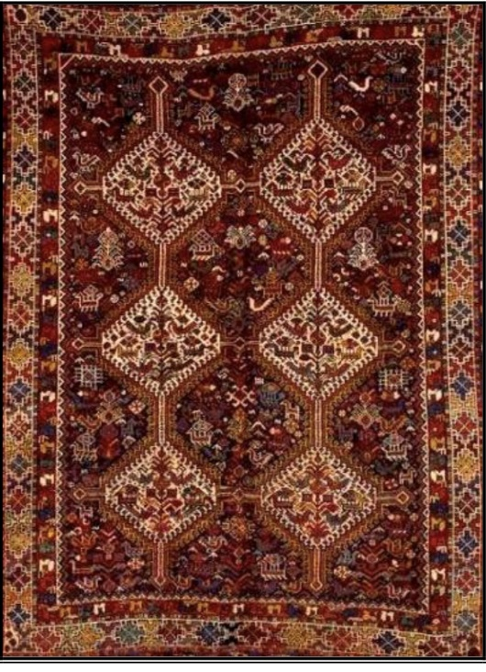 Kermanshah carpet

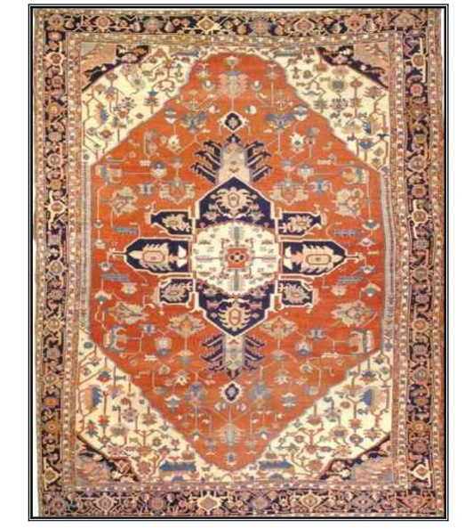Heriz carpet

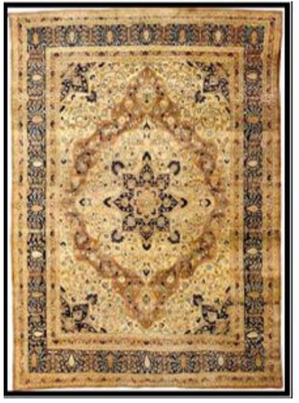 Tabriz carpet

